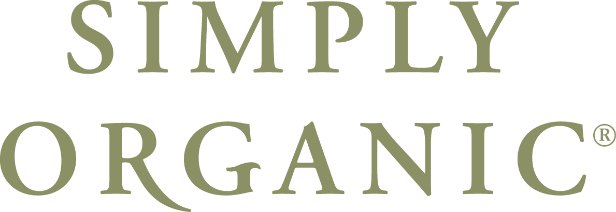
FOR IMMEDIATE RELEASE

Simply Organic Beauty Recognizes (Your name)_____________________ from
(Your Salon Name)______________________ As A Certified Organic Educator

Get expert training with products and services, and change your salon for the better

(DATE)__________________ (YOUR CITY)______________________ Receiving extraordinary, predictable hair color results can be challenging for the average hair stylist in the industry. Whether the struggle begins with the consultation or the stylist’s background with the product lines they are using, Simply Organic Beauty is dedicated to giving stylists the knowledge to achieve the precise color their clients desire. Simply Organic Beauty is committed to education as it pertains to the specialized organics market, and has chosen and trained stylists in the country. As we honor these top colorists and artists dedicated to their craft, Simply Organic Beauty intends on connecting salons with these certified credible educators. You and your clients should always expect the best and receive the best when using Simply Organic Beauty’s products, and the Color Certification taught by an Organic Educator will prepare your salon to meet these high standards.

(YOUR NAME) _____________________________at (YOUR SALON) ___________________________ has completed and passed all principles required to become and Simply Organic Beauty Certified Educator. Holding a comprehensive knowledge of organic hair principles, creative color, foil placement, color application and color correction, stylists are going to get both exceptional training, and incredible color results through the programs offered.

“Organic Educator Certification was specifically designed to spotlight the best organic color and product experts in our industry. People who are charismatic and passionate about teaching stylists how to use these amazing products,” says Rebecca Gregory, Vice President of Education for Simply Organic Beauty, “It is exciting to see the confidence our educators can bring to the salon, and the way those salons flourish with their newly gained knowledge.”

A stylist or salon that is certified by an Simply Organic Beauty Educator
(YOUR NAME) _____________________________ from
(YOUR SALON or CITY’S NAME)_________________________________,
please call (YOUR MAIN CONTACT NUMBER) ____________________________.

About (YOU & YOUR SALON):________________________________________________________
__________________________________________________________________________________
__________________________________________________________________________________
__________________________________________________________________________________

About Simply Organic Beauty:
Simply Organic Beauty (the “Company), headquartered in Palm Harbor, Florida, has been serving the professional salon industry since 2003. The company provides stylists with high performance products that maximize the use of gentle, nourishing, organic, and natural ingredients while minimizing the necessity for harsh or damaging chemicals. The company is the exclusive marketing and distribution company for several more natural and organic professional salon product lines featuring Simply Organic Beauty, throughout the United States and Canada. Simply Organic Beauty is a revolutionary full range of professional salon products including our tightly integrated color, curl, care, and control lines.

SimplyOrganicBeauty.com ∙ 35095 U.S. 19N., Suite 201, Palm Harbor, FL 34684 ∙ (888) 213-4744

